**Assignment 03**

**Data Cube**

Name: Puja Kawale

SJSUID: 0125-06156

Date: 10/03/2018

Data Cube: A multidimensional view of data that allows the pre-computation and fast accessing of summarized data*. (source: lecture slides)*

Please find below the hand drawn architecture of data cube generated with the help of data provided in problem statement.

Please note: In my submission, New York location comes before Los Angeles location. Hence, the data for New York resides in second slice where as the data for Los Angeles resides in third slice.

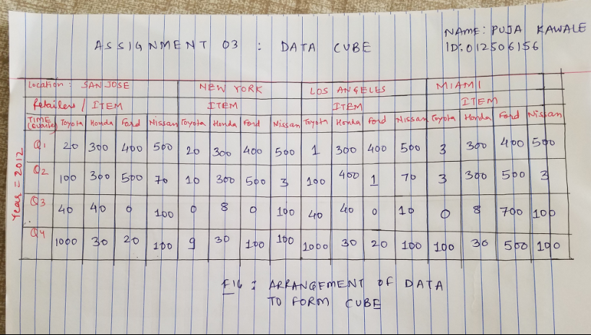

Fig.: Arrangement of data to form the data cube

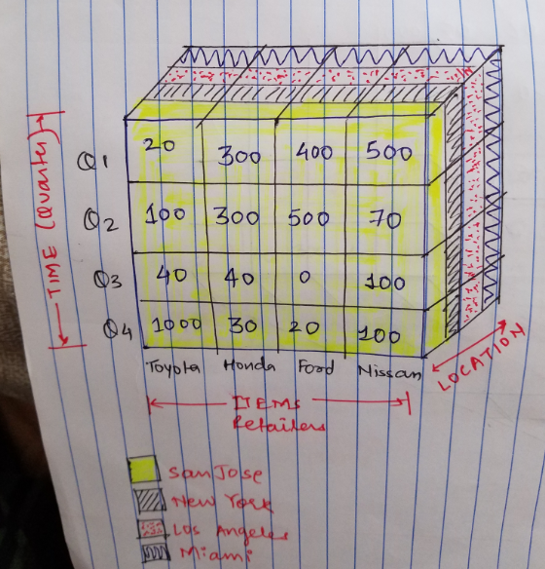

Fig.: Drill down Data cube 1

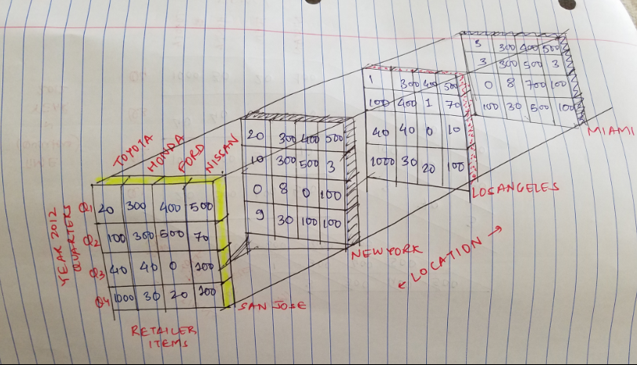

Fig: Drill down Data cube 2

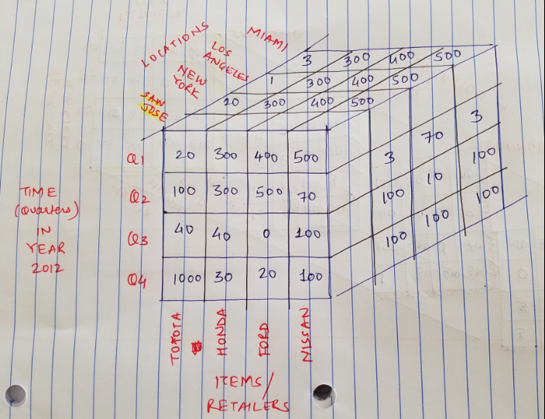

Fig.: A multidimensional Data Cube with all the data visible from all dimensions

Thank you !!